Farhad Ahmed

Computer Networking

10/01/18

**Wireshark Lab: HTTP**

Running ifconfig:

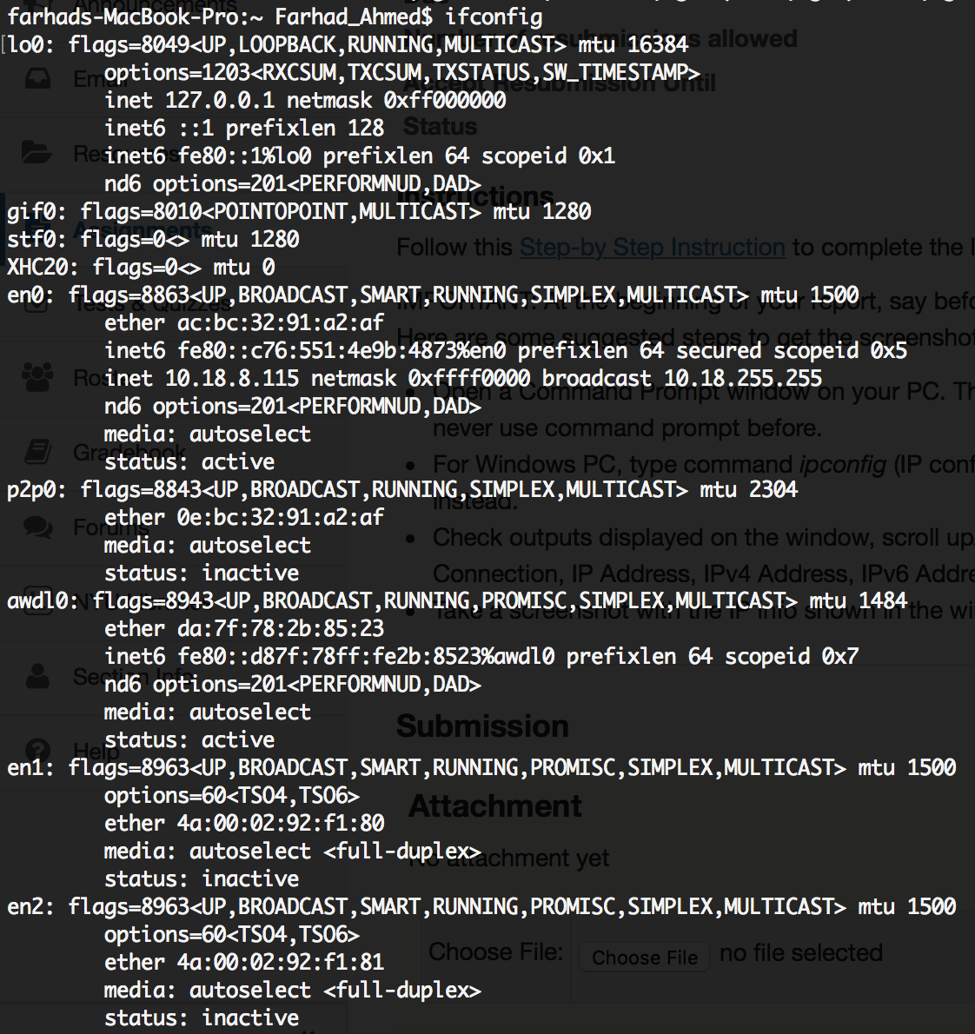

Part 1:

1. My browser is running HTTP version 1.1. The server is running HTTP version 1.1.
2. The languages accepted are en-us.
3. The IP Address of my computer is 10.18.8.115. The IP Address of the gaia.cs.umass.edu server is 128.119.245.12.
4. The status code returned from the server to the browser is 200 OK.
5. The last modified date of the HTML file Tue, 02 Oct 2018 05:59:02 GMT.
6. The content length is 128.
7. There are not any HTTP messages.

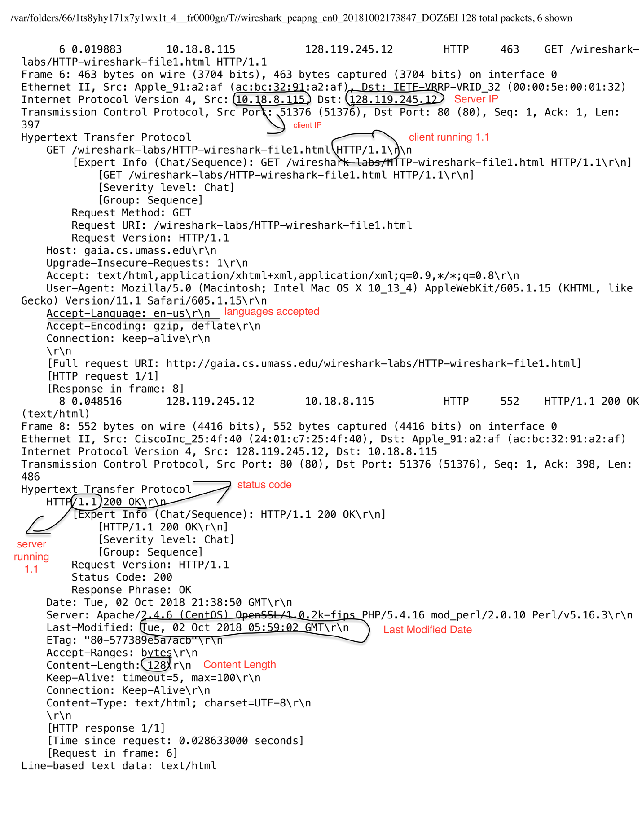

Part 2:

1. There is no IF-MODIFIED-SINCE in the first GET.
2. The contents of the server response is displayed within the packet and can be seen
3. Second Get has a IF-MODIFIED-SINCE.
4. Since the file wasn’t modified, the contents of the file were not displayed.

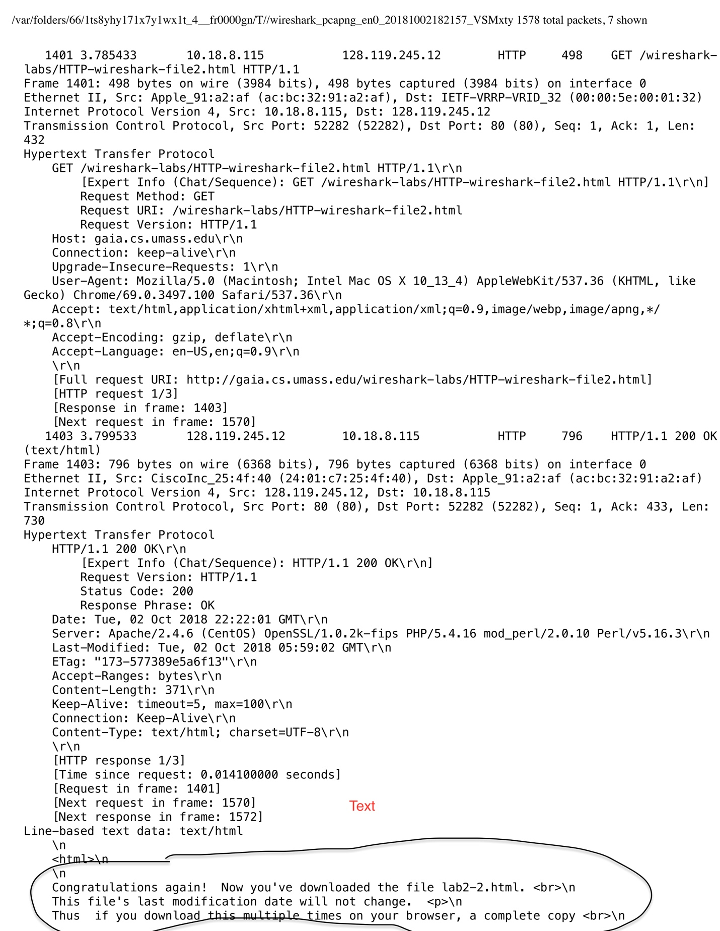

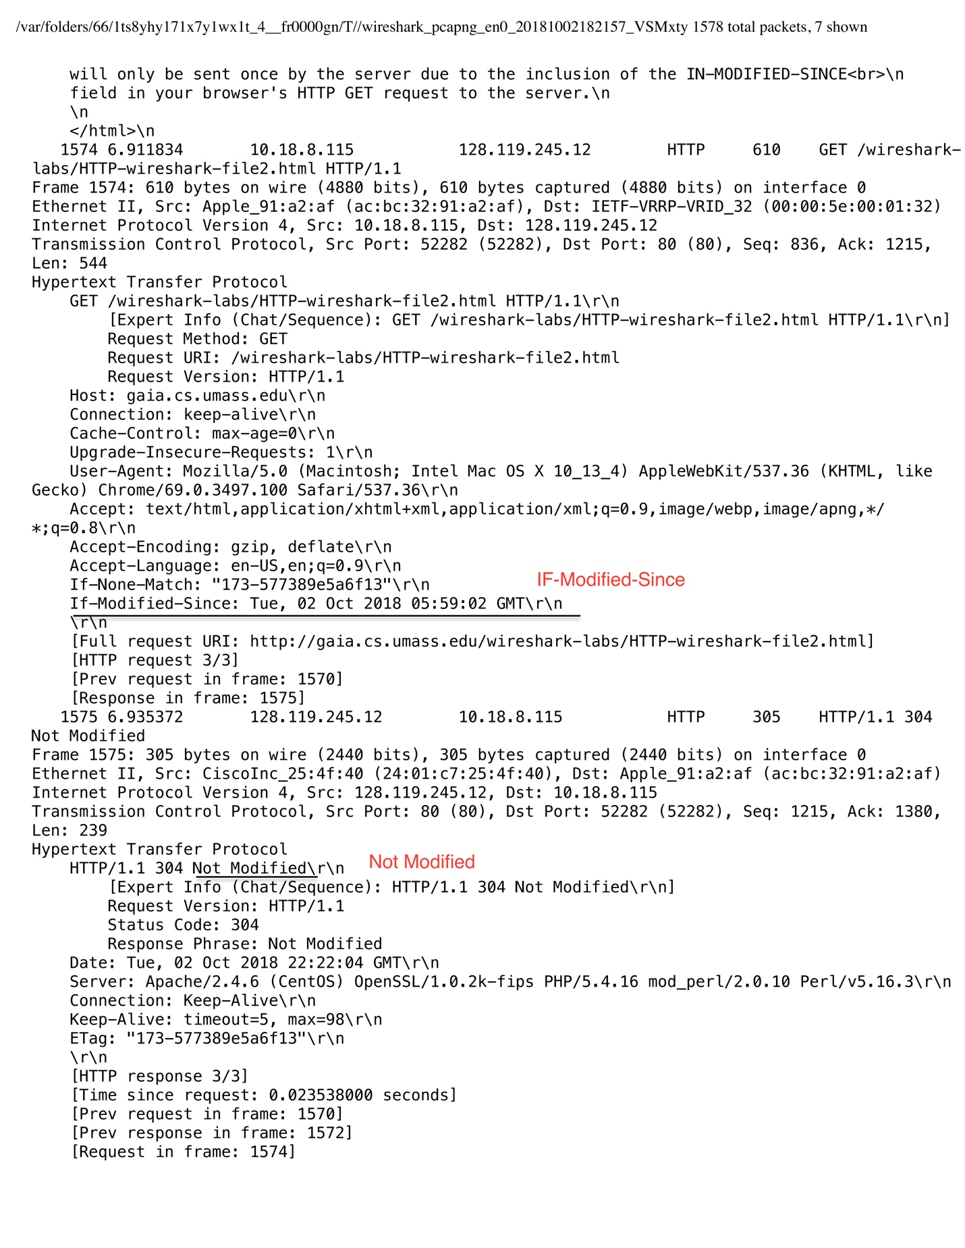

Part 3:

1. 1 packet sent from browser, 8th packet number gets message for bill of rights.
2. Packet 12 has the status code and phrase associated with the response.
3. Status Code 200 OK.
4. 3 packets were necessary to carry the single HTTP response.

Part 4:

1. The browser sent 3 HTTP GET messages, each message was sent to a different IP Address. Packet 12 was sent to 128.119.245.12, Packet 19 was sent to 165.193.123.218, and packet 22 was sent to 134.241.6.82.
2. The images were downloaded in parallel. The GET messages are in packets 19 and 22. But the replies with the images in them are in packets 27 and 56. The request for packet 20 was made before the first image was even finished.
3. The server’s response is 401 Authorization required.
4. When sending the HTTP GET message a second time a new field appears in the message. The field is Authorization: Basic.